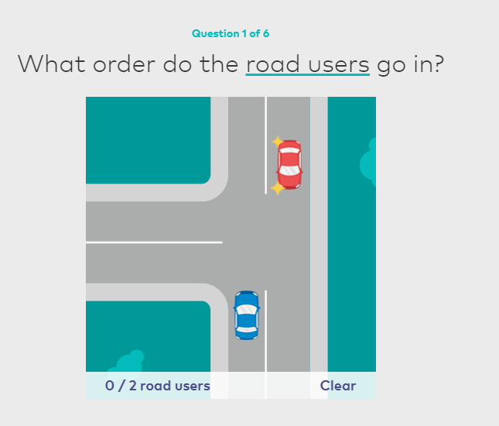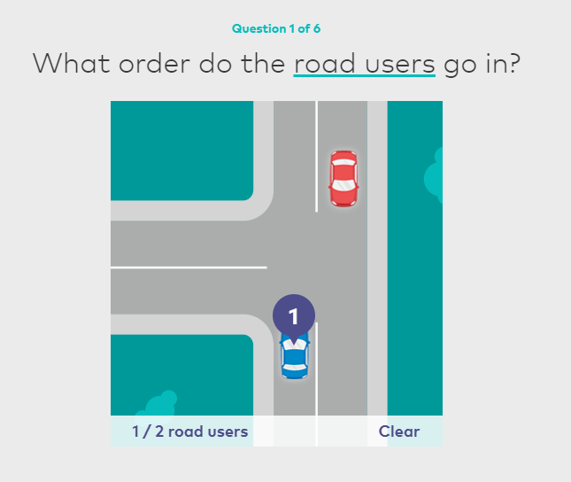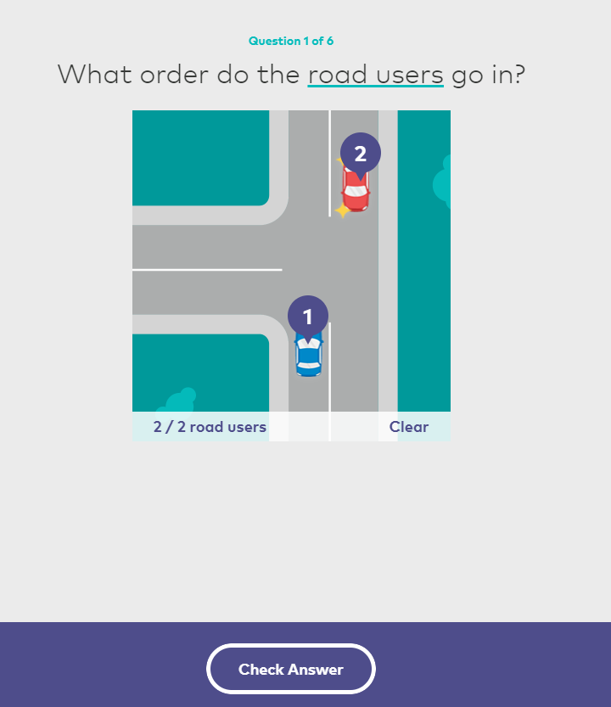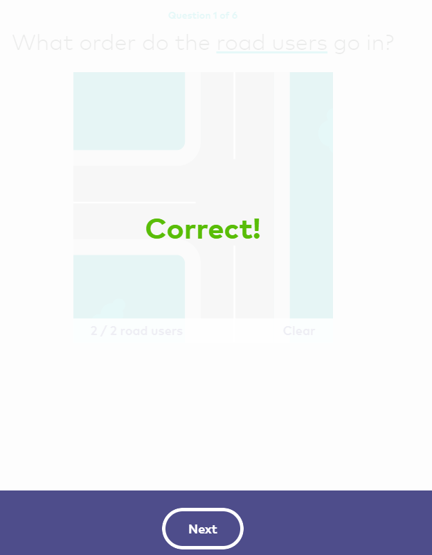

Basic animation elements necessary: movement (x/y axis), pop up,

Other possible basic animation elements: zoom, size (larger/smaller), scroll.

Idea: a map of multiple intersections. Traffic lights, give ways, stop signs, different lines (yellow, white), highways, fire station with lights, pilot vehicles.

The vehicle runs through an area scrolling past. The vehicle is not directly controlled but is directed by the user. As the user’s car meets intersections or cars it will stop, query the driver with the correct action, and then continue. Game ends if the incorrect choice is made.

A small map to the side for navigation.

Perhaps have tasks for the user (e.g. “go to the school”, “overtake a car”, “interact with a T intersection”, “correctly go through an intersection with traffic lights”).

Tasks:

1. Create the map
2. Have the car traverse the map
3. Create interactable focus points
4. Limit the scope to an area around the user’s car